|  |  |
| --- | --- |
| **Project:** | Test Plan |
| **Course:** | CSD460-J308 Capstone in Software Development |
| **Description:** | Testing the functional requirements of the Moffat Bay Lodge website D |
| **Date:** | <2025/02/03> |

To complete the test case plan, fill out the information for Project, Course, Description and Date in the header below.

.

**TABLE OF CONTENTS**

# **<Test 1>** Test plan for the requirement “**Provide users with an error message when leaving fields empty**”

**<Test 2>** Test plan for the requirement **“Provide users with an error message when entering incorrect credentials.”**

**<Test 3>** Test plan for the requirement **“Prevent form submission when required fields are empty.”**

**<Test 4>** Test plan for the requirement “**Test plan for the requirement “Ensure all navigation links lead to the correct pages.”**

**<Test 5>** Test plan for the requirement **“Prevent form submission when required fields are empty (Registration Form).”**

**<Test 6>** Test plan for the requirement **“Ensure password input meets security standards.”**

|  |  |  |  |  |
| --- | --- | --- | --- | --- |
| Test 1 | Test plan for the requirement “**Provide users with an error message when leaving fields empty**” | | | |
|  | **Test Objective:** Ensure that the login form does not accept empty fields. | **Developer:** Taib Elbaroudi  **Date tested:** <2025/02/01> | **Peer tester: Joe Huffer**  **Date tested:** <2025/02/03> | |
| **Step** | **Action** | **Expected results:** | **Developer pass/fail** | **Tester pass/fail** |
| 1 | Navigate to the login.html | Login page loads without errors. | YES | YES |
| 2 | |  | | --- | | Click "Login" without entering any data. |  |  | | --- | |  | | An error message appears: “Please fill out this field." | YES | YES |
| 3 | Enter only a username, leave the password empty, and click "Login." | An error message appears: “Please fill out this field." | YES | YES |
| 4 | Enter only a password, leave the username empty, and click "Login." | An error message appears: “Please fill out this field." | YES | YES |
| **Comments** | This test plan successfully confirms that when fields are left empty, a custom error message is shown to the user **(“Please fill out this field.").** | | | |

1. **Test Case 1 | Test Performed:**

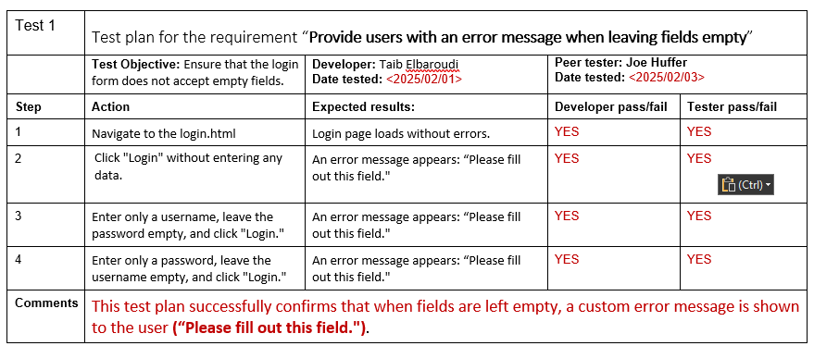

**Test Results Screenshot:**

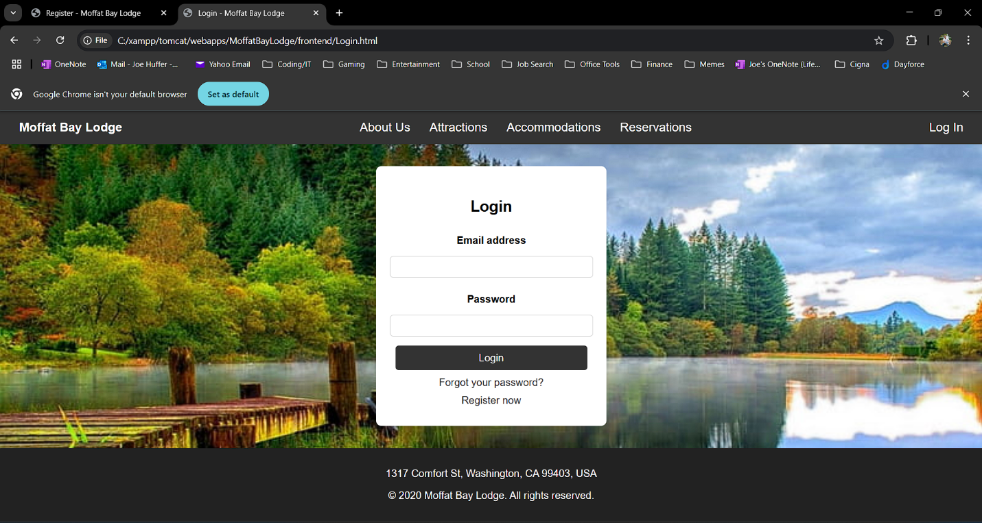

1. 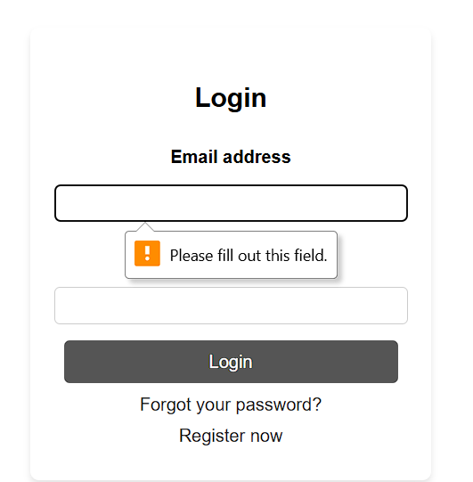
2. 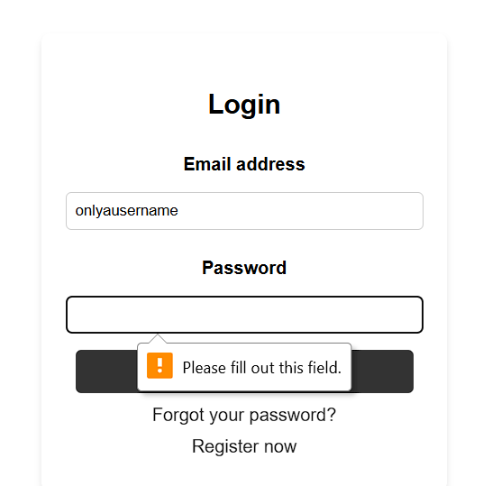

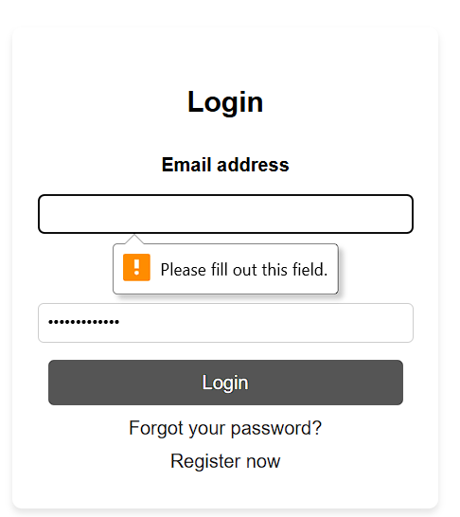

|  |  |  |  |  |
| --- | --- | --- | --- | --- |
| Test 2 | Test plan for the requirement “**Provide users with an error message when entering incorrect credentials.**” | | | |
|  | **Test Objective:** Verify that incorrect login inputs show an error message and do not redirect users to the following page. | **Developer:** Taib Elbaroudi  **Date tested:** <2025/02/01> | **Peer tester: Joe Huffer**  **Date tested:** <2025/02/03> | |
| **Step** | **Action** | **Expected results:** | **Developer pass/fail** | **Tester pass/fail** |
| 1 | Navigate to the login.html | Login page loads without errors. | YES | YES |
| 2 | Enter an incorrect email or password. | Fields accept input. | YES | NO |
| 3 | Click the "Login" button. | Error message appears: "Please enter a valid email or password." | YES | NO |
| 4 | Verify login is not allowed. | User is not redirected and prompted to enter a valid email or password. | YES | NO |
| **Comments** | This test plan successfully confirms that when incorrect credentials are entered, a custom error message is shown to the user **(“Please enter a valid email or password.")**  Notes from Tester (Joe Huffer): On step 2, I registered a new user with the screenshot credentials, I also attempted to load and run our example sql scripts (all 4), ensured the sql server was running, and then clicked submit.  - I entered that data into the login page, and the page simply refreshed with empty boxes. Does not seem to test stored table or store data from registration page.  - When all fields are empty, “Please fill out this field” does populate – that is good. | | | |

1. **Test Case 2 | 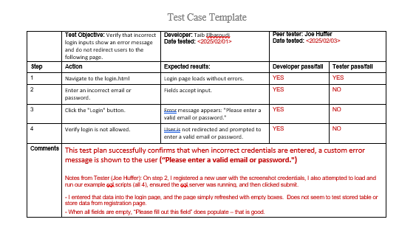Test Performed:**

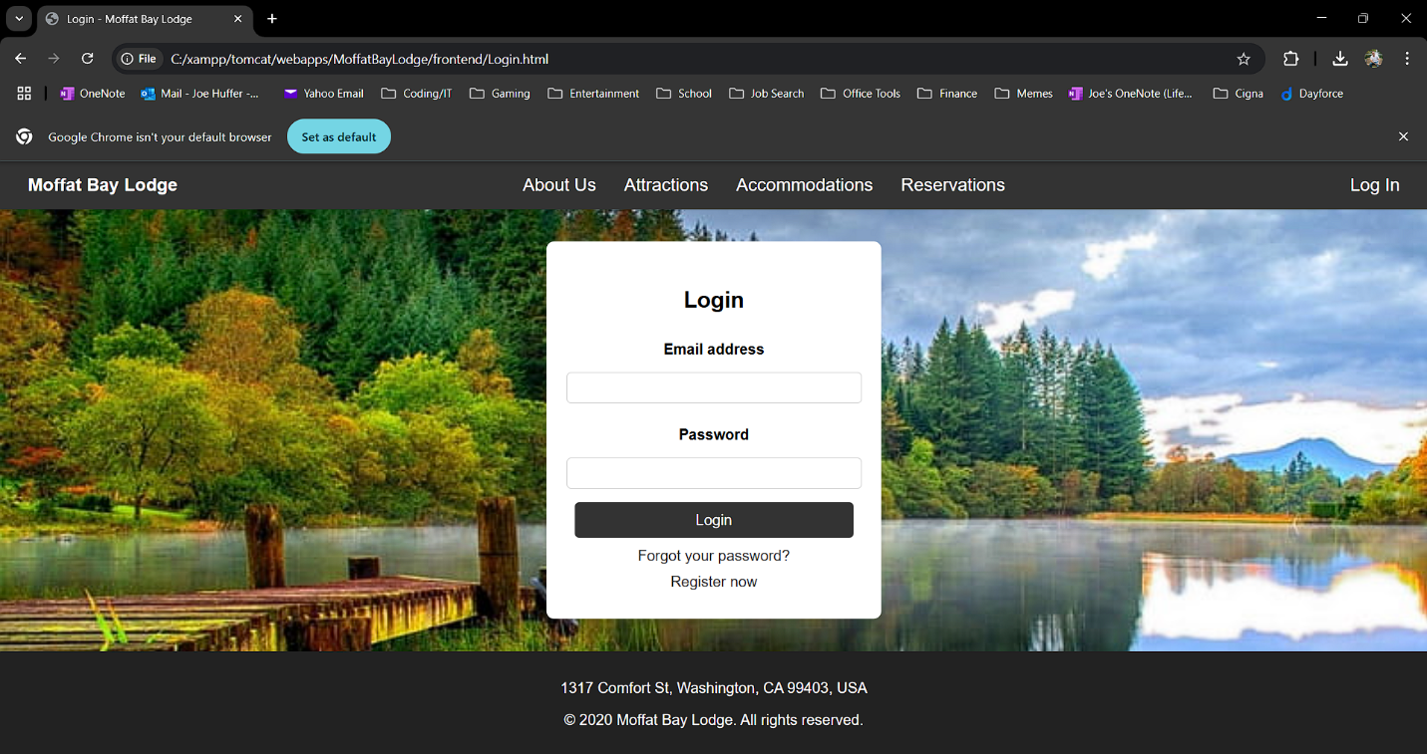

1. **Form Clears regardless of credentials. No validation/storage**



1. **No Error, Form Clears**
2. **No Errors, Form Clears**



|  |  |  |  |  |
| --- | --- | --- | --- | --- |
| Test 3 | **Test plan for the requirement:** "Prevent form submission when required fields are empty." | | | |
|  | **Test Objective:** Ensure that users cannot submit the booking form without filling in the required fields. | **Developer: Matthew Gamboa**  **Date tested:** <2025/02/02> | **Peer tester: Joe Huffer**  **Date tested:** <2025/02/03> | |
| **Step** | **Action** | **Expected results:** | **Developer pass/fail** | **Tester pass/fail** |
| 1 | Navigate to index.html | The landing page loads without errors. | YES | YES |
| 2 | Scroll down to the "Book Your Stay" section. | The form is visible with fields: Name, Email, Date, and Submit button. | YES | YES |
| 3 | Click "Submit" without entering any data. | An error message appears: "Please fill out this field." | YES | YES |
| 4 | Enter only a name, leave the email and date empty, then click "Submit." | The browser should prompt the user to fill in the missing fields. | YES | YES |
| 5 | Enter an invalid email (e.g., "test@") and click "Submit." | An error message appears: "Please enter a valid email address." | YES | YES |
| 6 | Enter a valid name, email, and date, then click "Submit." | The form submits successfully. | YES | YES |
| **Comments** | This test plan ensures that **users cannot submit the form with missing or invalid inputs** and that proper validation messages appear.  Tester Notes: All tests Pass | | | |

**Test Case 3 | Test Performed:**

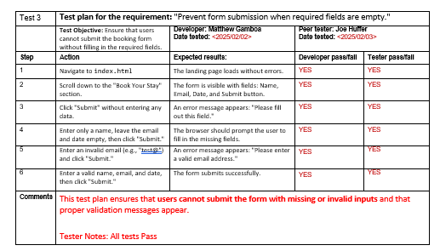

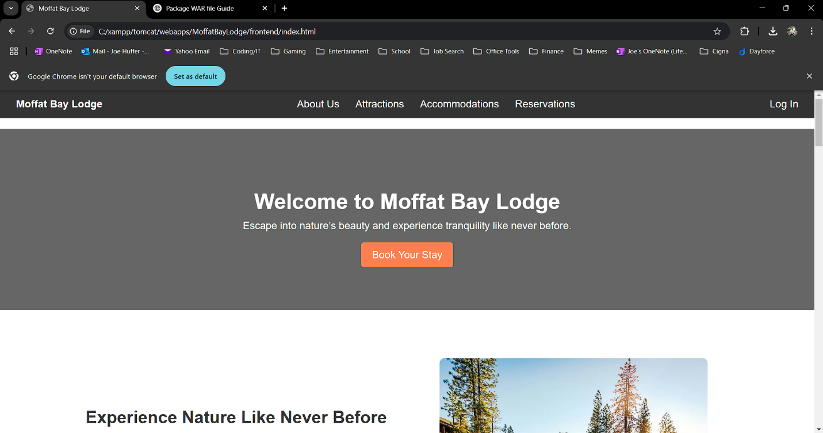

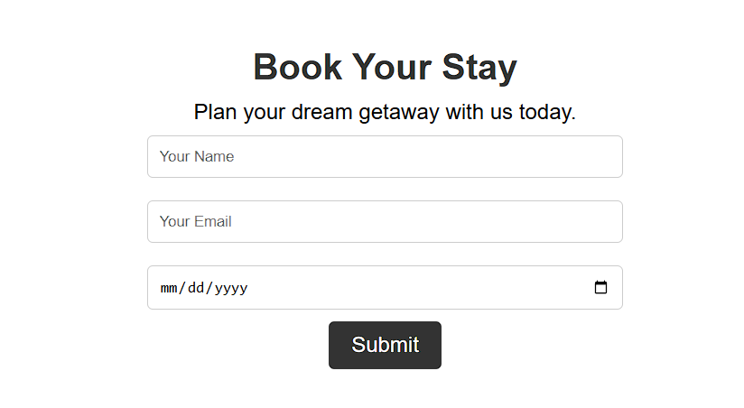

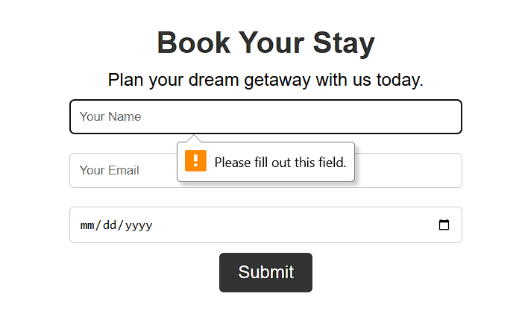

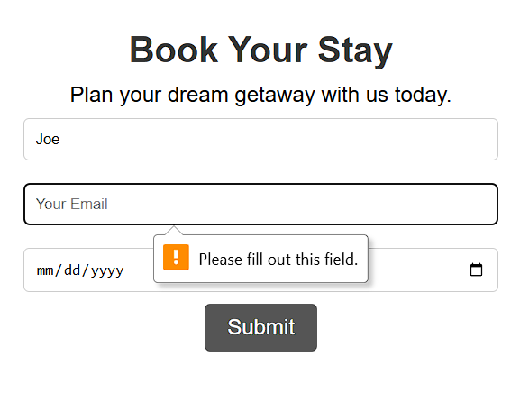

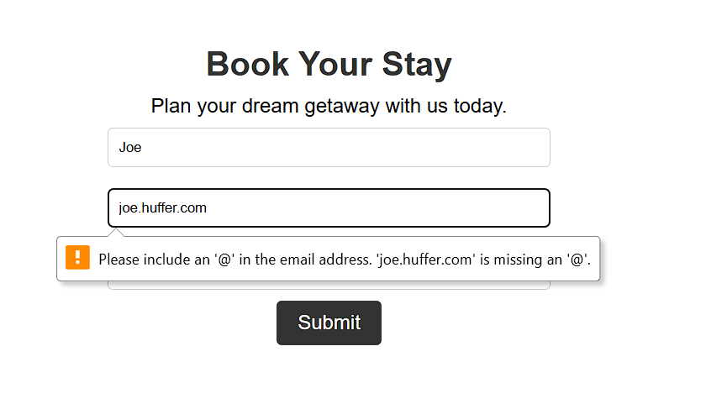

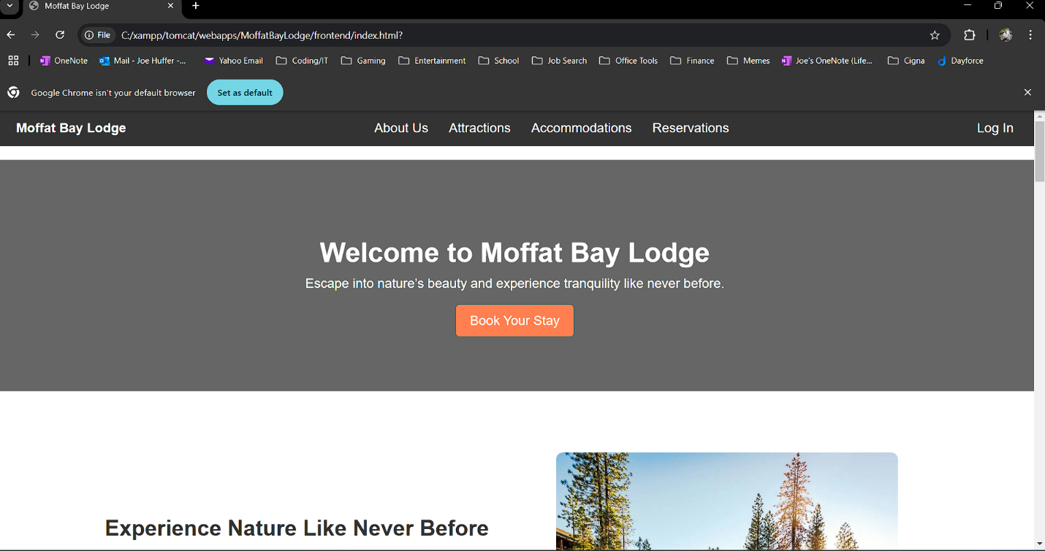

|  |  |  |  |  |
| --- | --- | --- | --- | --- |
| Test 4 | **Test plan for the requirement:** "Ensure all navigation links lead to the correct pages." | | | |
|  | **Test Objective:** Verify that all links in the navigation bar work correctly and direct users to the right pages. | **Developer: Matthew Gamboa**  **Date tested:** <2025/02/02> | **Peer tester: Joe Huffer**  **Date tested:** <2025/02/03> | |
| **Step** | **Action** | **Expected results:** | **Developer pass/fail** | **Tester pass/fail** |
| 1 | Navigate to index.html | The landing page loads without errors. | YES | YES |
| 2 | Click on "About Us" in the navigation bar. | The browser navigates to about.html. | NO | NO |
| 3 | Click on "Attractions" in the navigation bar. | The browser navigates to Attractions.html. | NO | NO |
| 4 | Click on "Accommodations" in the navigation bar. | The browser navigates to Accommodations.html. | NO | NO |
| 5 | Click on "Reservations" in the navigation bar. | The browser navigates to Reservations.html. | NO | NO |
| 6 | Click on "Log In" in the navigation bar. | The browser navigates to Login.html. | YES | YES |
| **Comments** | This test ensures that all **navigation links work correctly**, preventing broken links or incorrect page redirections.  Tester Notes: Some HTML Files are built – all that are built function correctly. The pages that are not built return “Your file cannot be accessed” | | | |

|  |  |  |  |  |
| --- | --- | --- | --- | --- |
| Test 5 | **Test plan for the requirement:** "Prevent form submission when required fields are empty." | | | |
|  | **Test Objective:** Ensure that users cannot submit the registration form without filling in all required fields. | **Developer: Matthew Gamboa**  **Date tested:** <2025/02/02> | **Peer tester: Joe Huffer**  **Date tested:** <2025/02/03> | |
| **Step** | **Action** | **Expected results:** | **Developer pass/fail** | **Tester pass/fail** |
| 1 | Navigate to register.html | The registration page loads without errors. | YES | YES |
| 2 | Locate the registration form. | The form is visible with fields: First Name, Last Name, Telephone, Email, Password, and Submit button. | YES | YES |
| 3 | Click "Create Account" without entering any data. | An error message appears: "Please fill out this field." | YES | YES |
| 4 | Enter only the first name, leave the other fields empty, then click "Create Account." | The browser should prompt the user to fill in the missing fields. | YES | YES |
| 5 | Enter an invalid email (e.g., "test@") and click "Create Account." | An error message appears: "Please enter a valid email address." | YES | YES |
| 6 | Enter a valid name, email, phone number, and password, then click "Create Account." | The form submits successfully. | YES | YES |
| **Comments** | Tester Notes: All tests Pass | | | |

**Test Case 4 | Test Performed:**

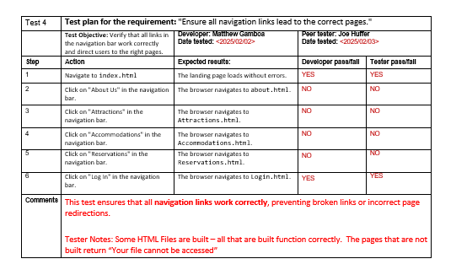

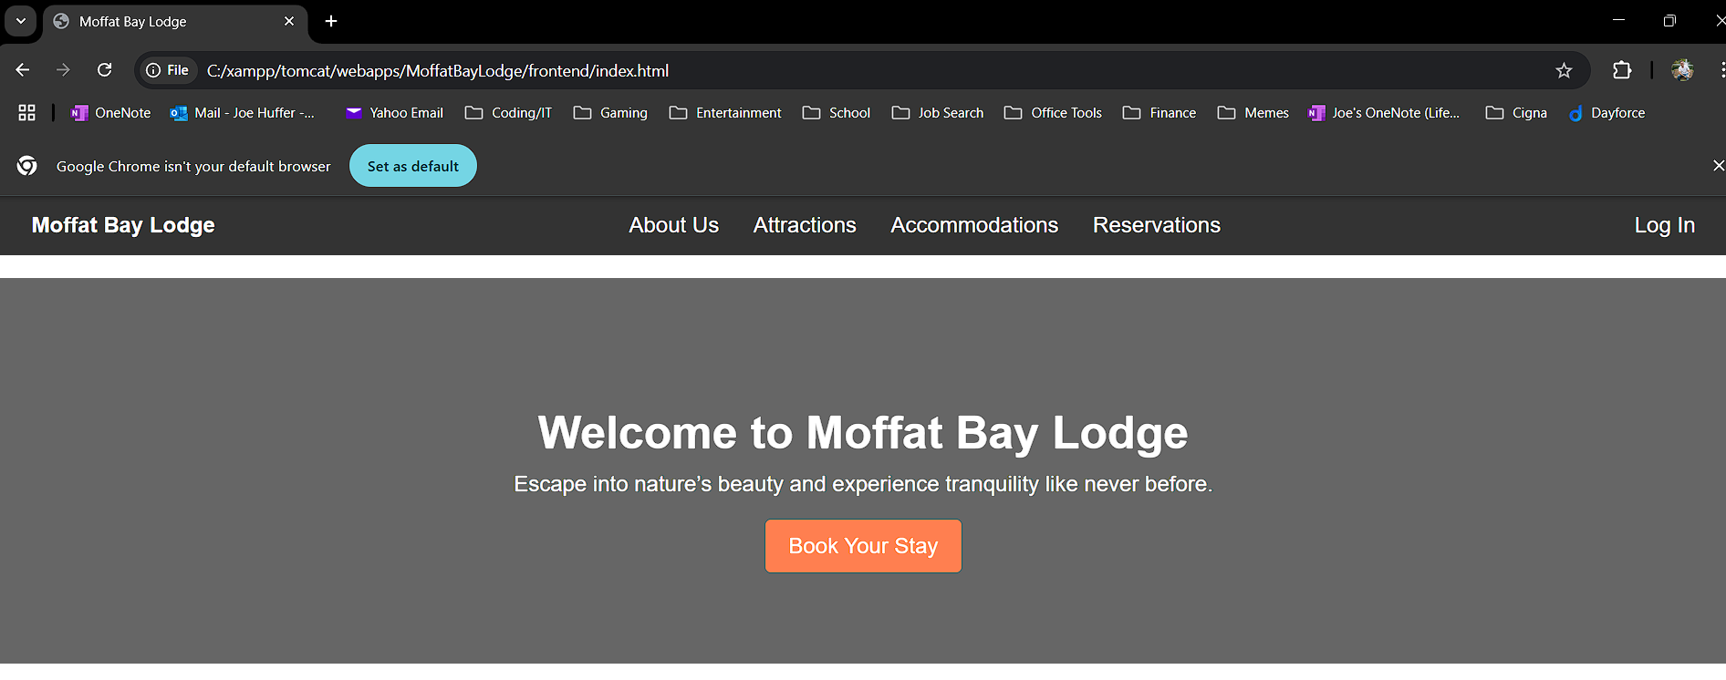

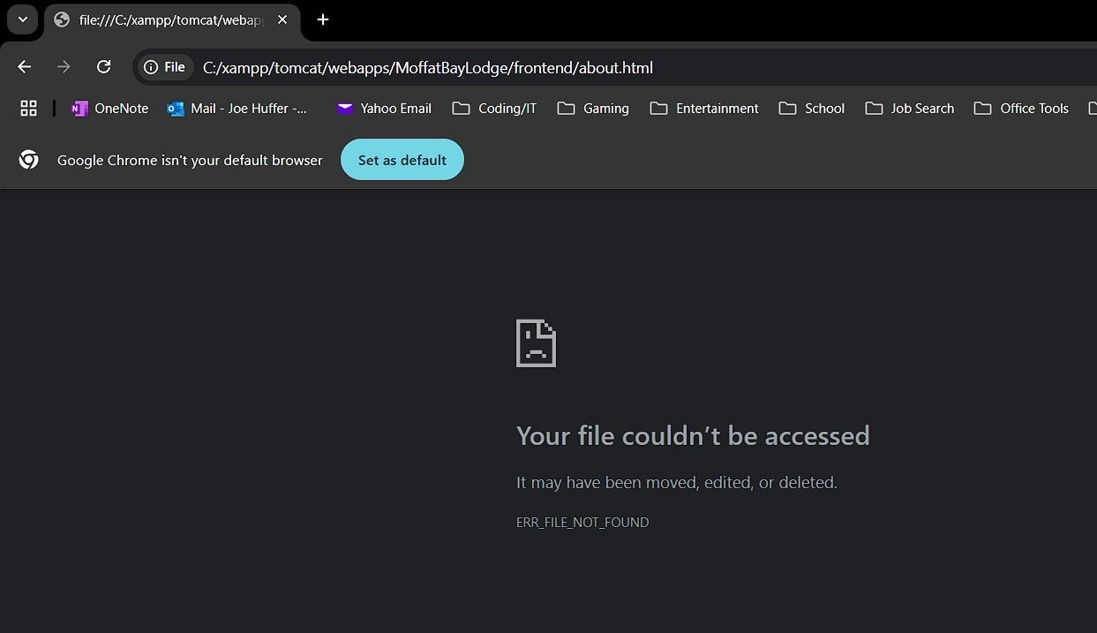

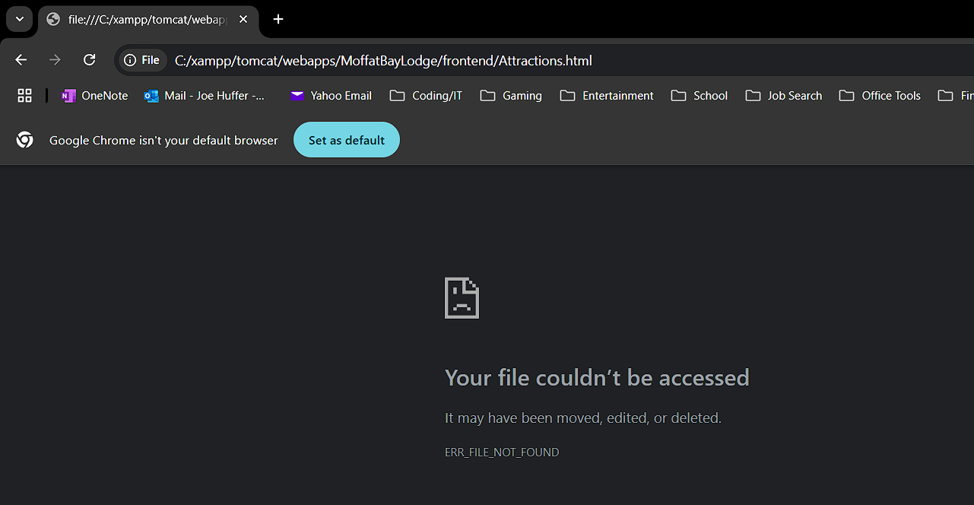

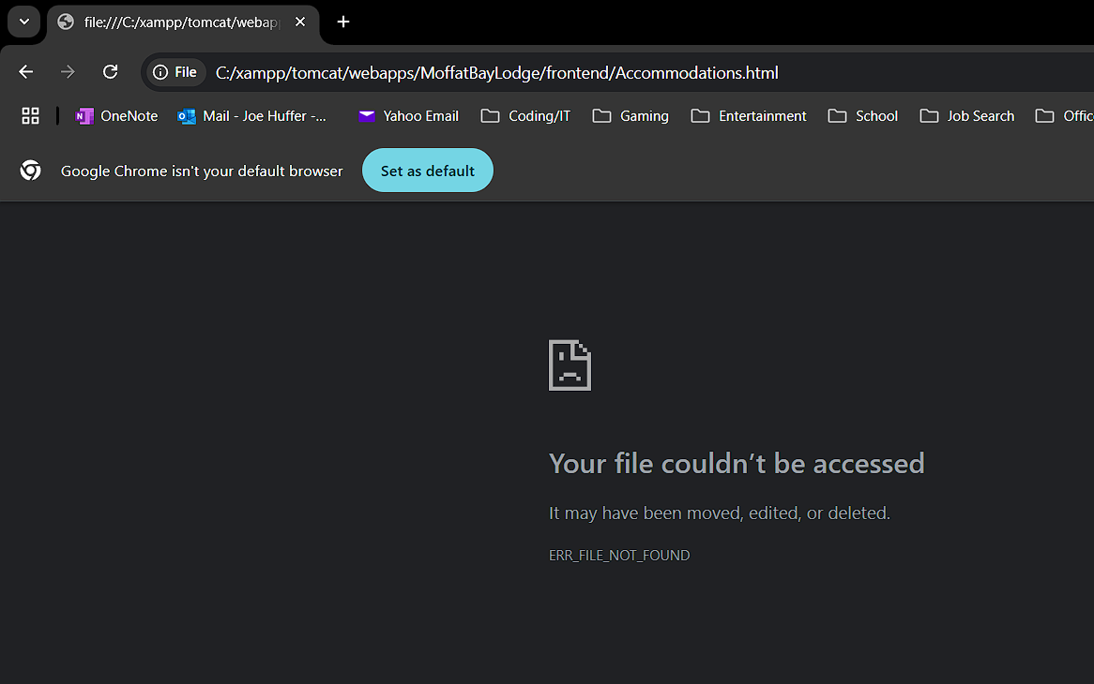

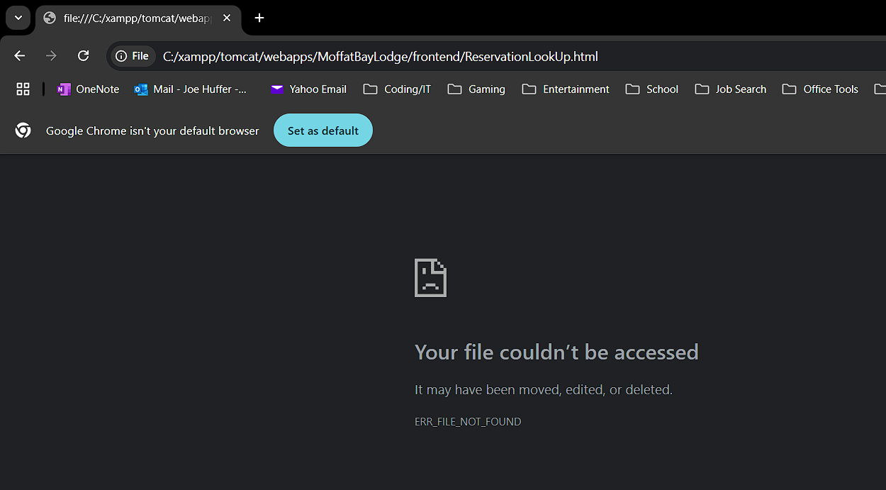

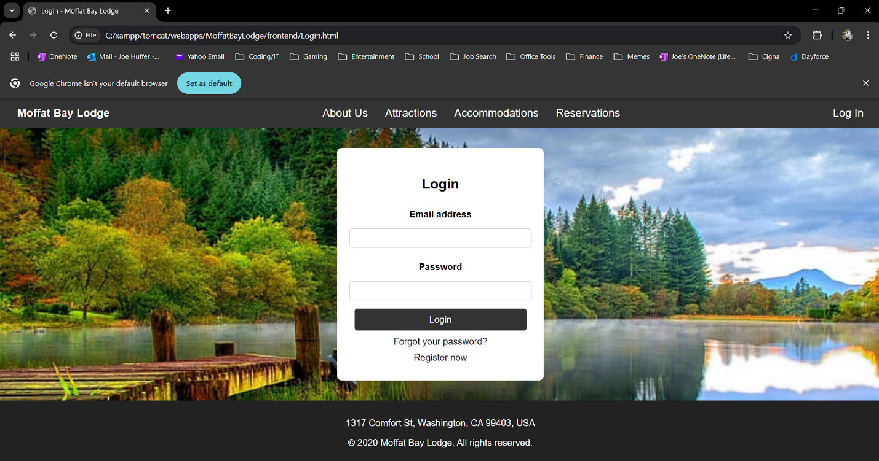

|  |  |  |  |  |
| --- | --- | --- | --- | --- |
| Test 6 | **Test plan for the requirement:** "Ensure password input meets security standards." | | | |
|  | **Test Objective:** Verify that the password field enforces input validation, including minimum length and required complexity. | **Developer: Matthew Gamboa**  **Date tested:** <2025/02/02> | **Peer tester: Joe Huffer**  **Date tested:** <2025/02/03> | |
| **Step** | **Action** | **Expected results:** | **Developer pass/fail** | **Tester pass/fail** |
| 1 | Navigate to register.html | The registration page loads without errors. | YES | YES |
| 2 | Locate the password field. | The password input field is visible. | YES | YES |
| 3 | Enter a password shorter than 6 characters and click "Create Account." | An error message appears: "Password must be at least 6 characters long." | YES | NO |
| 4 | Enter a simple password (e.g., "123456") and click "Create Account." | If password requirements exist, an error message should prompt for a stronger password. | YES | NO |
| 5 | Enter a secure password (e.g., "Moffat2025!") and click "Create Account." | The form submits successfully. | YES | NO |
| **Comments** | Tester Notes:   * No errors populate HTML page as they would for error or email missing an ‘@’ symbol. * When data is put in each field, and if you clear the email ‘@’ symbol requirement, the form clears and refreshes. * Putting NO for Test 6. See next point.   - I entered data for all fields. If data is in all fields, and a valid or invalid input is placed within password, the form submits regardless. | | | |

**Test Case 6 | Test Performed:**

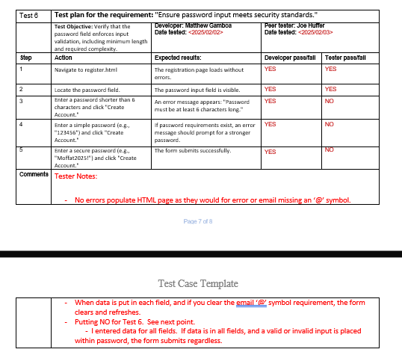

1. **T**

